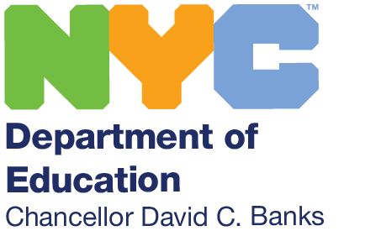 | THE NEW YORK CITY DEPARTMENT OF EDUCATION  Dr. Philip A. Composto, Community Superintendent – DISTRICT 30  28-11 Queens Plaza North – 5th Floor - Long Island City, New York 11101  Telephone: 718-391-8323 Facsimile: 718-391-6147 - email: pcompos@schools.nyc.gov
July 2022

Dear Families and Friends of District 30,

I would like to take the opportunity to extend my gratitude to the District 30 community and families on being reappointed as Superintendent. I am proud and honored to have been selected by Chancellor Banks to lead one of the most diverse districts in the New York City Department of Education. As an educator with over forty years of experience, I have a clear vision for the future that is guided by these four “NEAT” beliefs:

- Never being satisfied in pursuit of excellence.
- Everyone’s participation is essential to our success.
- ALL children can learn and succeed.
- Treat people the way you want to be treated.

In our district, we have aligned our mission of providing a world class education in a safe, nurturing, and culturally responsive environment to the Chancellor’s four pillars. I firmly believe that this work will be accomplished through the collaborative efforts of responsible students, involved parents, supportive community, and dedicated staff.

Our schools will continue to leverage a variety of programs for students to think critically and creatively, work collaboratively, be problem solvers, and function in an information and technologically driven society. Such programs include Computer Science for All, Science, Technology, Engineering, Arts, and Mathematics (STEAM), Civics for All, Algebra for All, and Universal Literacy. Next, in order to scale and sustain what works, we will continue to provide a wide variety of programs that will enhance the growth and development of all students including our multilingual learners and students with Individualized Education Plans (IEPs). Some of these programs include Dual Language, Inclusion Education, Magnet Schools, Gifted and Talented Programs, Early Childhood Education and the Save for College Program. I am happy to say that through our partnership with the NYC Kids Rise, our students in Pre-K through the fourth grade have opened and contributed to scholarship accounts totaling over $1.6 million opening pathways for higher education for our children.

As superintendent, I value the input of families, students, staff, and the community. As a result, our District will be engaging the community in Listening & Learning Tours to elicit feedback and suggestions on the ways in which we can improve on what works and find innovative ways to personalize learning for our students.

I am energized to begin a new school year in which we can embark on a collective journey to support a reimagined learning experience for our students. In 2018, we obtained community input that was used to create a plan through the New York State Integration Project-Professional Learning Community (NYSIP-PLC) Grant to support the development of staff in the heart and mind work necessary to transform teaching and learning. The heart work addresses the social emotional needs of students, examines implicit bias, and ensures representation. This is the Culturally Responsive and Sustaining part of the work. The mind work supports the development of students and staff in co-creating the conditions for learning and developing the 4 Habits of Mind: Voice, Co-creation, Social Construction, and Self-Discovery.

As part of this plan, we scheduled workshops for families on how they can support their child at home in this work. All workshops are translated into Spanish, Bangla, and Arabic and are recorded to provide families access to the sessions and resources provided. As part of this work, we will be amplifying student voice, including students in the co-creation of lessons and projects, allowing opportunities for students to improve upon their work through social construction with their peers, and providing student opportunities for self-discovery and reflection. These attributes will serve to promote students to pursue aspirations, investigate problems, design solutions, chase curiosities, and create performances.

I am deeply humbled to be your Superintendent and am committed to serving and supporting our students, staff, and families. I am incredibly grateful to the District 30 community for your continued support and collaboration. In District 30, our guiding principle is “Always remember to ask...how is this good for ALL children?” We will continue to partner and work together to personalize students’ educational experiences that will activate their imagination, interest, and passion for learning.

I look forward to gathering input from our families and community members through our Listening & Learning Tours to reimagine learning for our students. Please feel free to connect with me at pcompos@schools.nyc.gov with any questions or concerns. I wish you and your families a healthy, joyful, and safe summer.

Sincerely,
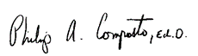

Dr. Philip A. Composto
Community Superintendent – D30

